1. **Project Objective:**

**Amazon Sales Analysis**

* To analyze and understand customer purchasing patterns and behaviors within the Amazon database.
* To identify key drivers of sales across different branches and product lines.
* To provide actionable insights to enhance marketing strategies and improve customer satisfaction.

1. **Methodology:**
2. **Data Cleaning:**

* Cleaned the dataset to remove duplicates and irrelevant entries.
* Checked for missing values and addressed gaps in the database.

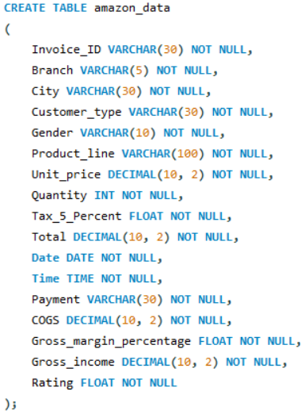

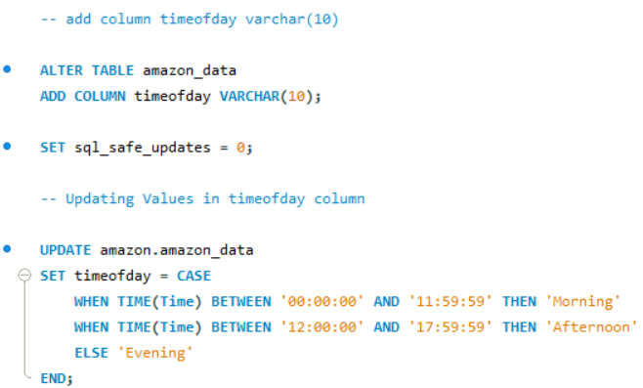

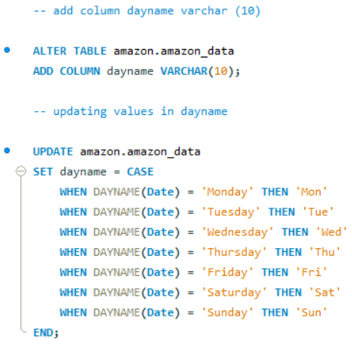

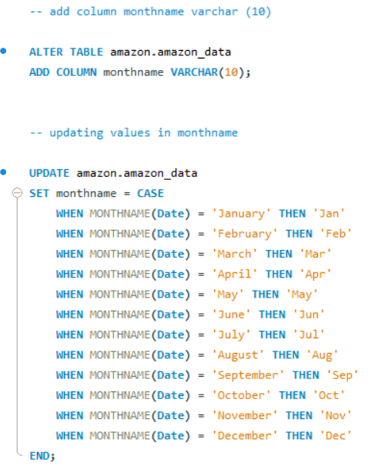

1. **Data Extraction:**

* Utilized SQL queries to access and extract relevant data from the amazon_data table.

1. **SQL Queries:**

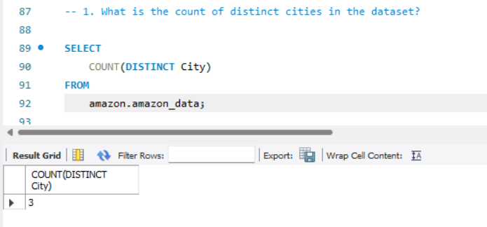

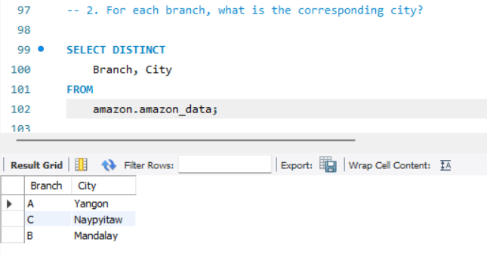

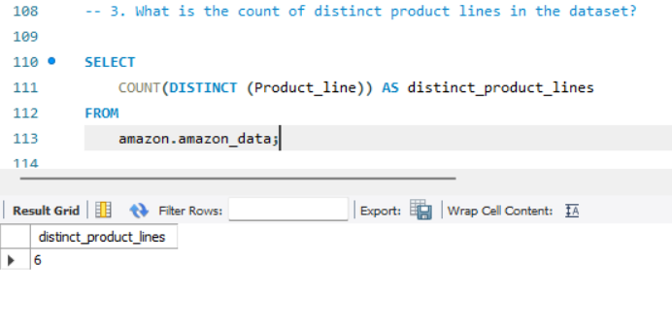

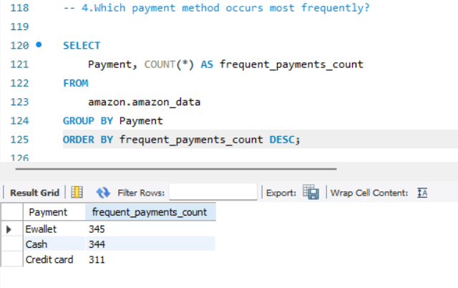

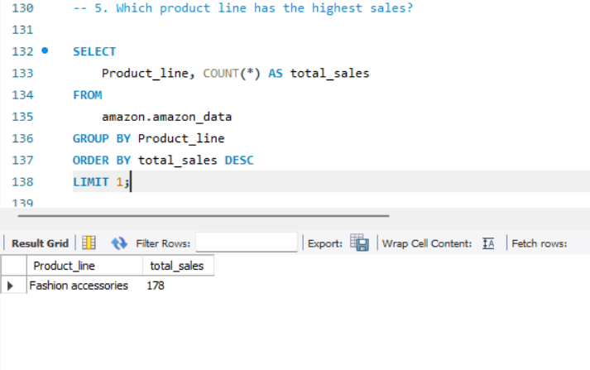

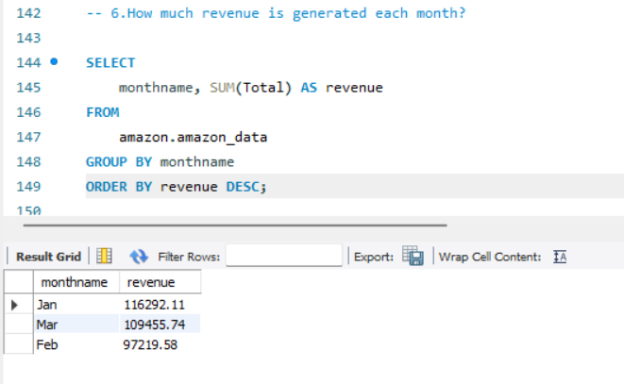

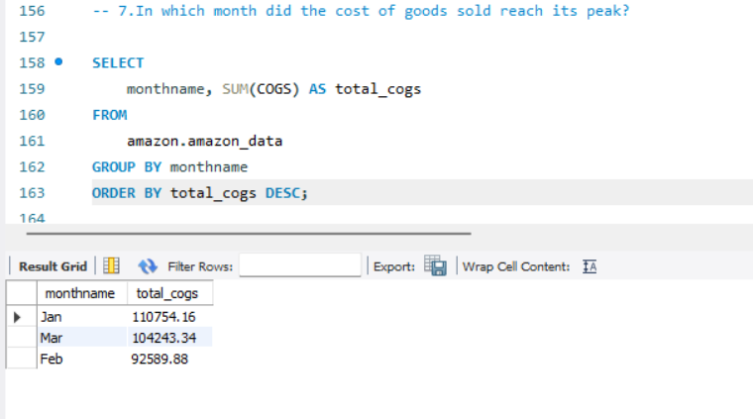

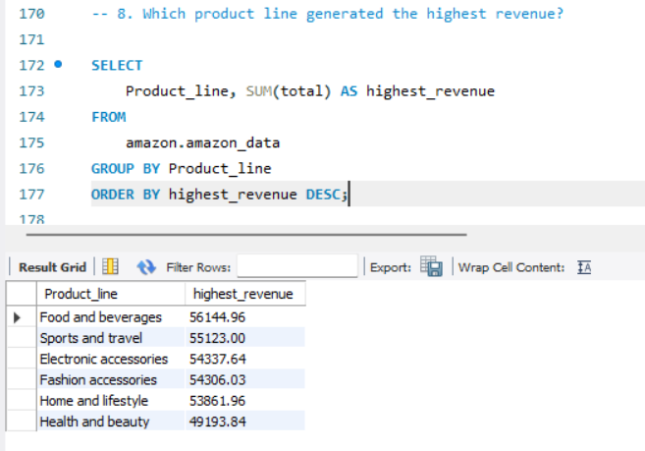

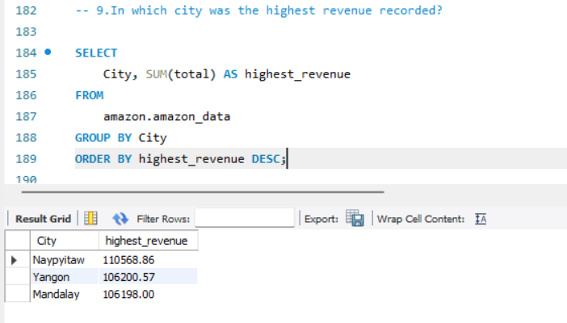

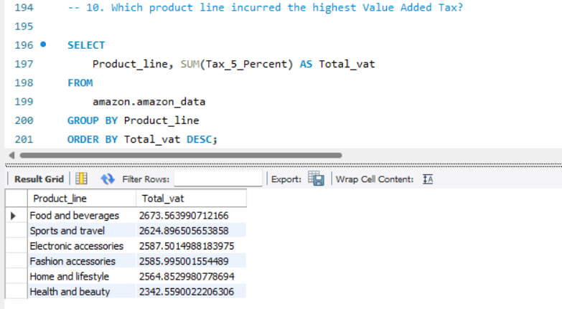

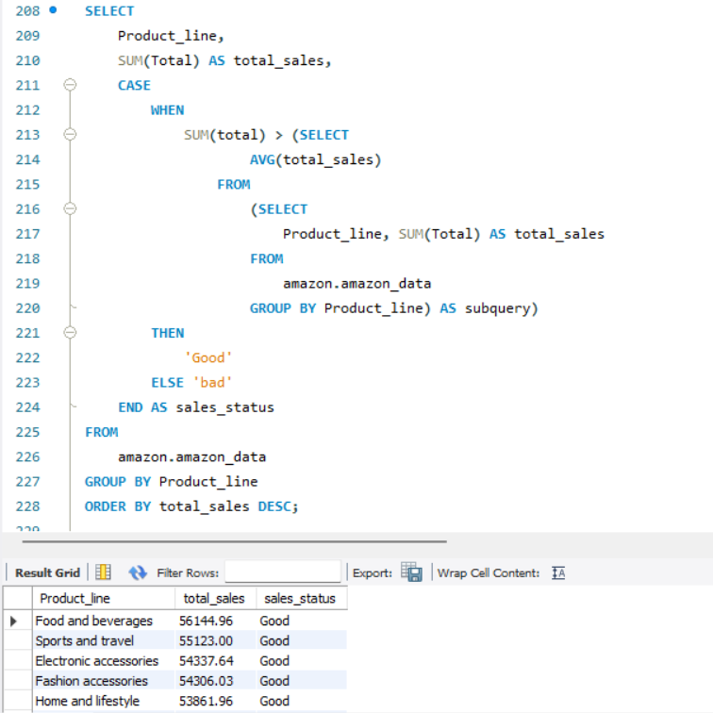

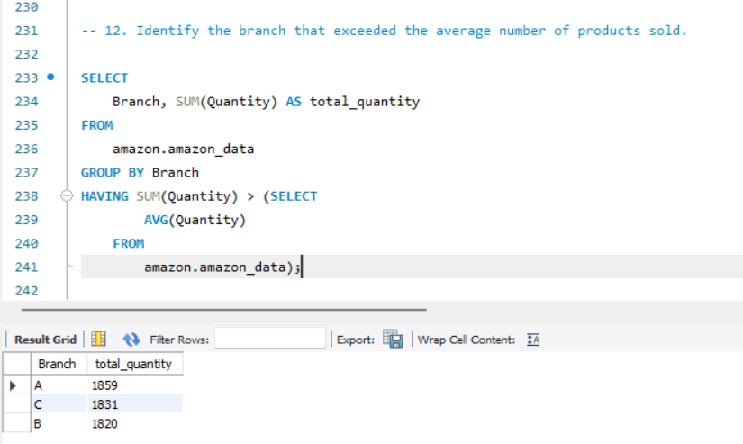

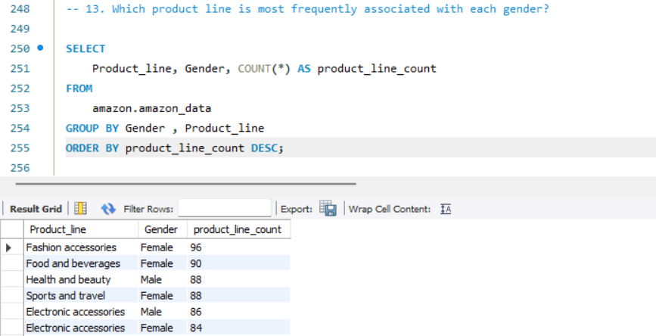

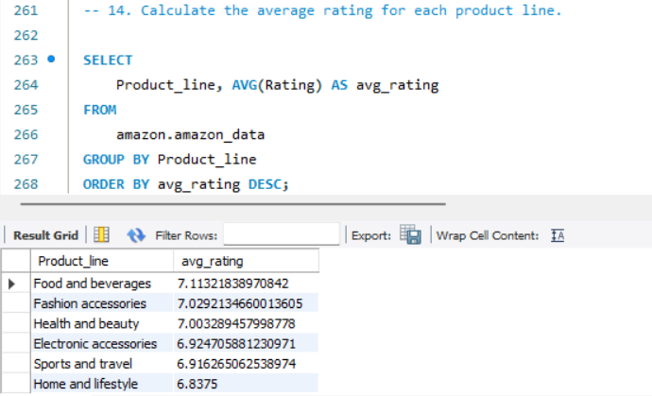

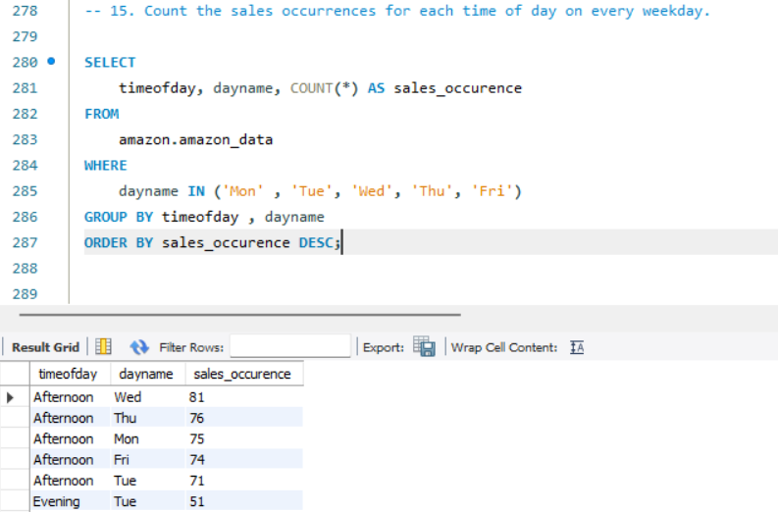

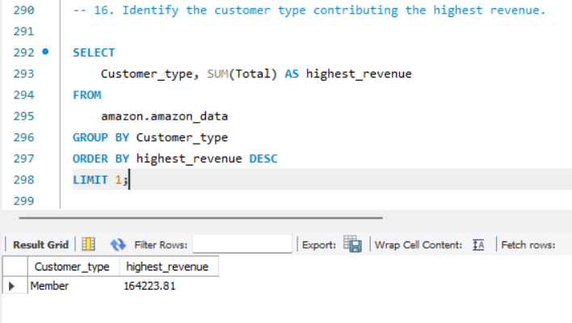

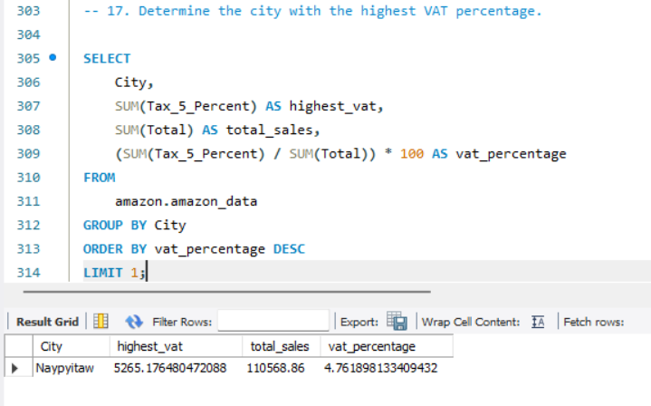

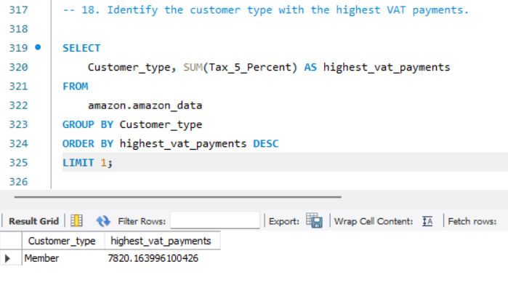

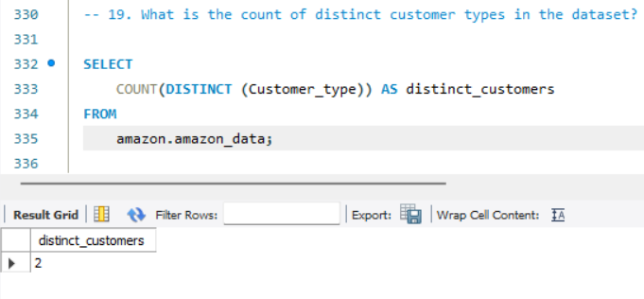

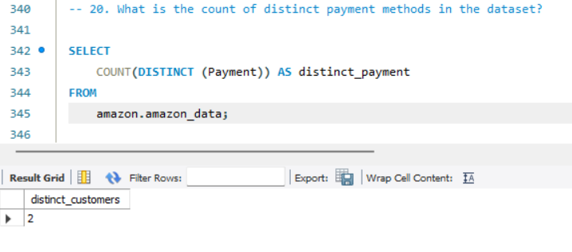

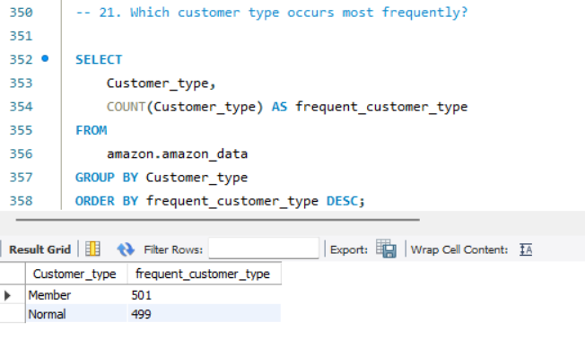

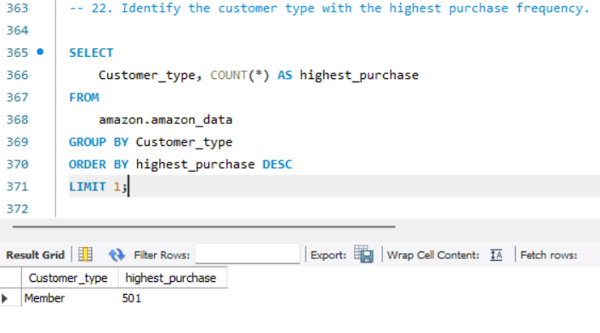

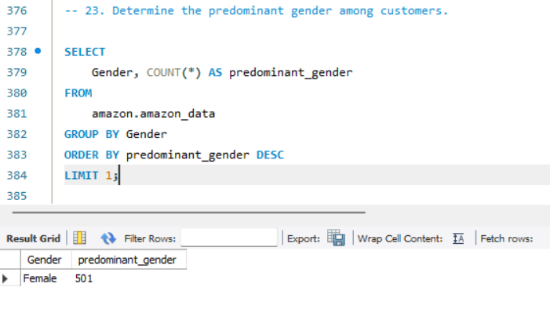

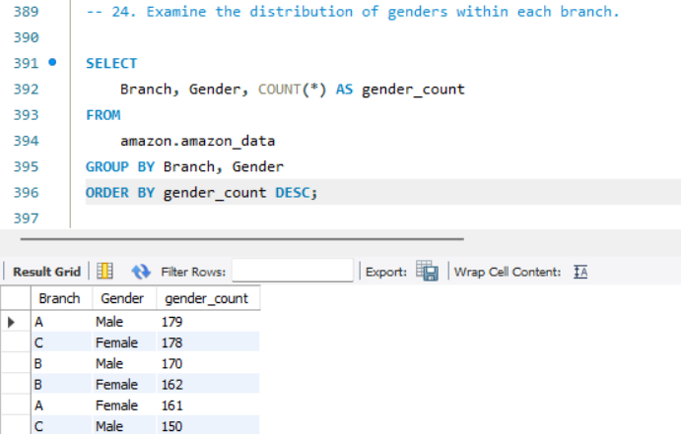

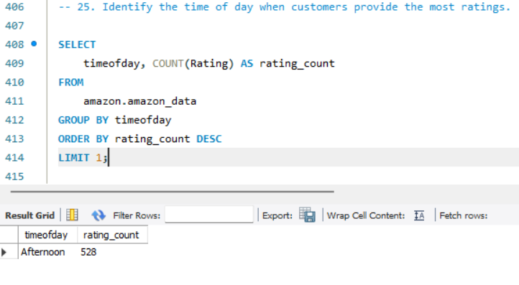

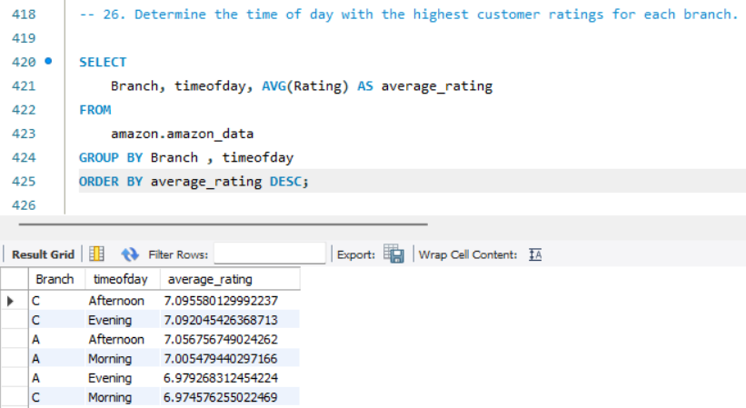

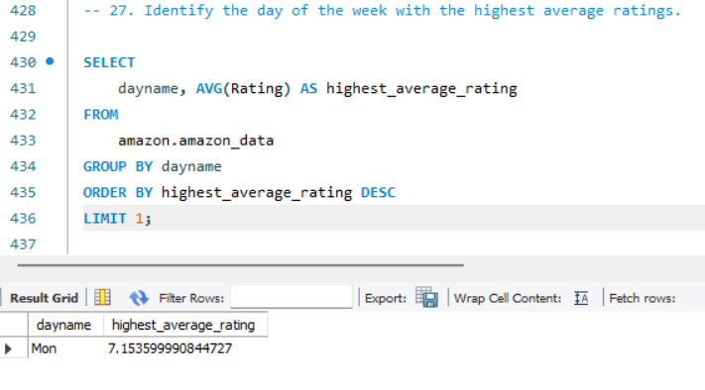

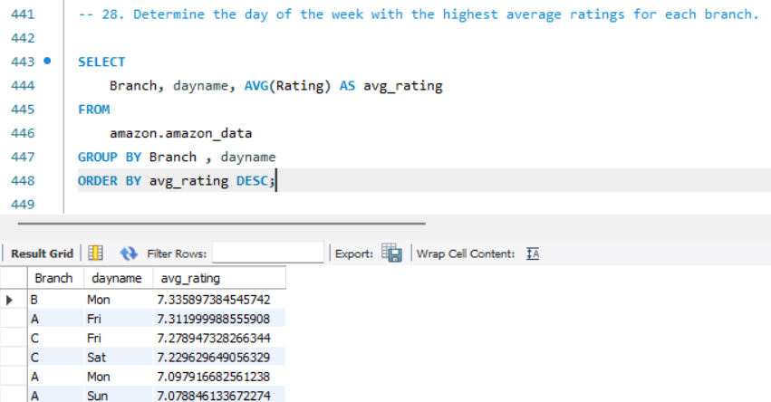

1. **Key Insights**
2. **Customer Types and Revenue:**

* The **Member** customer type generates the highest revenue at **$164,223.81** and accounts for the highest number of transactions, with **501** purchases.
* There are **two distinct customer types**: Member and Normal.
* In terms of VAT payments, Members also lead with **$7,820.16** in contributions.

1. **Sales Distribution:**

* The branches and their corresponding sales figures indicate that the **Fashion Accessories** product line is the most sold, totalling **1,859** **units**.
* The **highest revenue generated by product lines** includes:
* Food and Beverages: **$56,144.96**
* Sports and Travel: **$55,123.00**
* Electronic Accessories: **$54,337.64**
* Fashion Accessories: **$54,306.03**

1. **Geographical Insights:**

* The city with the highest VAT percentage is **Naypyitaw**, with total sales of **$110,568.86**, making it the city with the highest revenue overall.
* The distribution of customers across branches indicates varying preferences, with Men primarily purchasing Health and Beauty products (88 purchases), whereas Women predominantly buy Fashion Accessories (96 purchases).

1. **Rating Patterns:**

* The **Afternoon** is the time of day when most ratings are given, totalling **528 ratings.**
* Mondays have the highest average rating (**7.1536**), and the **average ratings by branch** reveal Branch B performs best on Mondays with an average of **7.3359.**

1. **Payment and Taxation:**

* The most frequently used payment method is **Ewallet**, with **345 transactions**, followed closely by **Cash** and **Credit Card.**
* **Food and Beverages** incurred the highest VAT at approximately **$2,673.56**, indicating its significant sale volume.

1. **Time of Purchases:**

* Highest sales occurrences reported during the **afternoon** on Wednesdays, followed by Thursdays and Mondays, suggesting a peak shopping period mid-week.

1. **Gender Distribution:**

* The predominant gender among customers is **Female**, with a total of **501 purchases**, while male purchases are notable as well, especially in Health and Beauty.

1. **Conclusion**

* This analysis highlights the importance of member customers in terms of revenue generation, the dominance of particular product lines and sales patterns geographically and temporally, and the behaviors around customer ratings and payment methods.
* Notably high sales in specific branches indicate potential for targeted marketing strategies to increase foot traffic.
* Understanding time-based trends allows for the optimization of sales strategies, including staff allocation and promotion timing.

**Implications for Business Decisions:**

* Marketing campaigns should focus on Member engagement and targeted offers to maximize revenue.
* Inventory management can be improved by aligning stock levels with high-demand product lines and anticipated sales peaks.
* Enhancing customer experience during peak hours could lead to increased satisfaction and repeat purchases.